**Initial Design:**

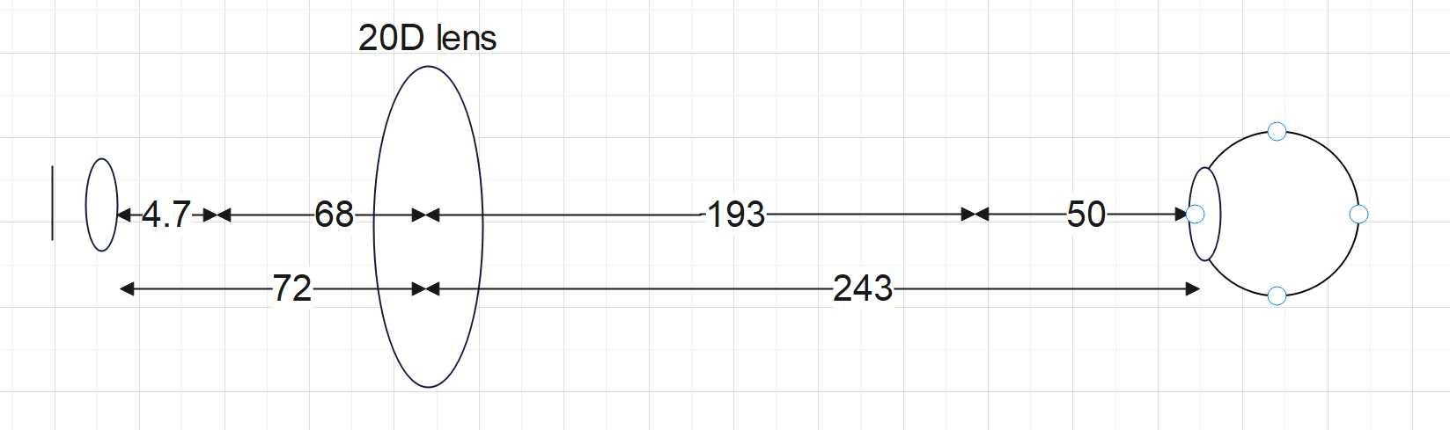

* Only uses 1 20D lens → very cheap
* Distance to focus to the camera is very large → will result in a low resolution image
* As there is only 1 lens we have much less ability to adjust the light path and focus the image

**Second Design with much stronger lens:**

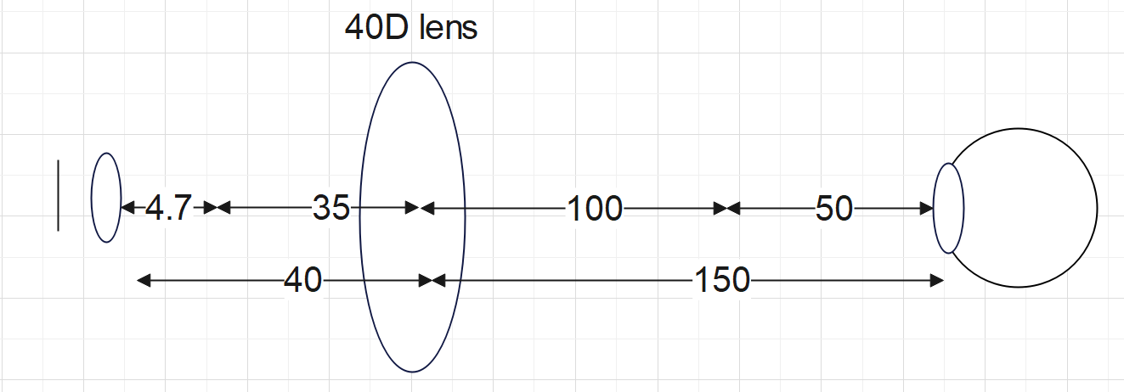

* Much stronger lens reduces the distance of the setup
* 40D lens exponentially more expensive than original 20D lens
* Only have 1 lens for adjustments

**Final Lens Design:**

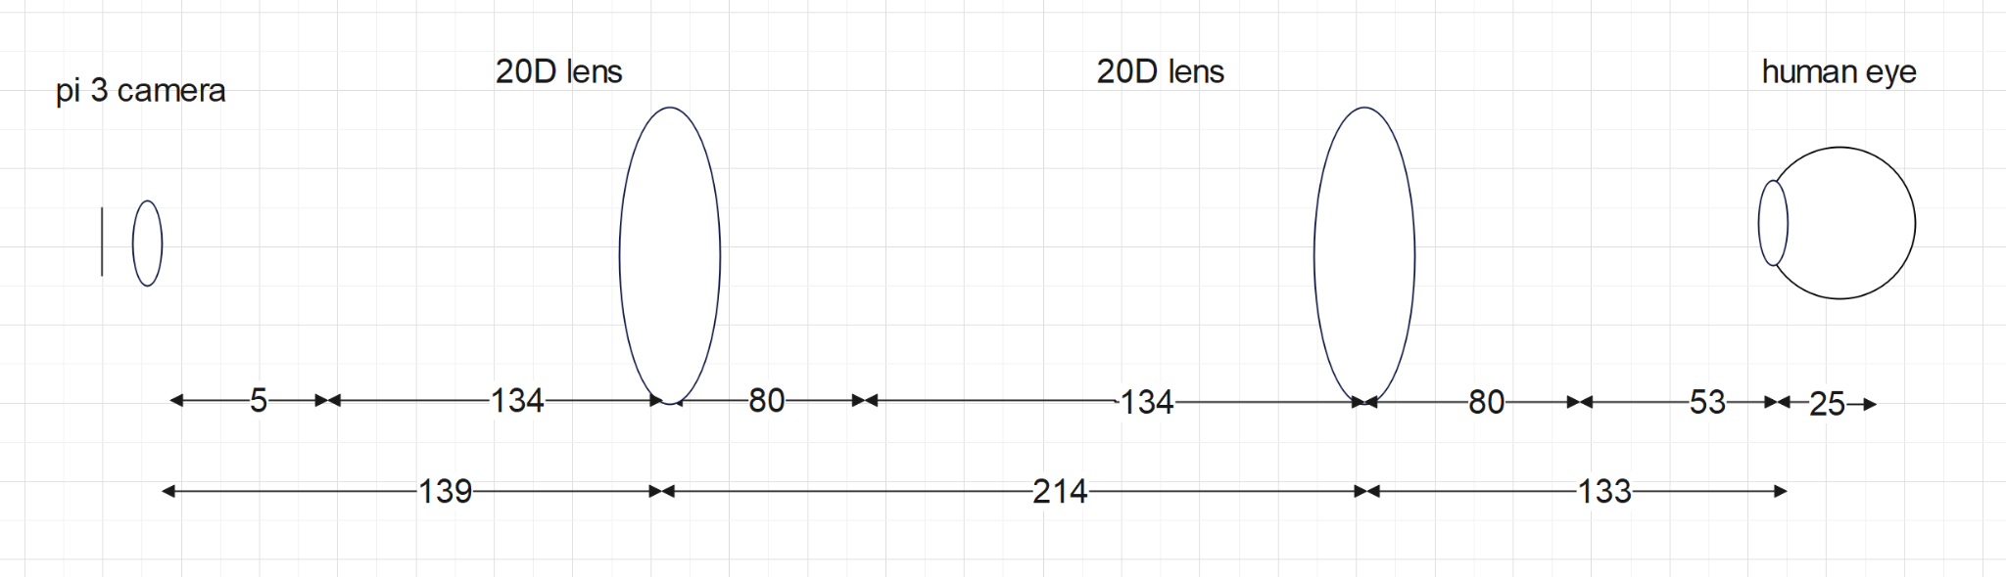

* Much longer setup but we believe much more reliable
* Magnification split between 2 lenses - image remains small passing through lens (only use the centre)
* Have 2 lenses for adjustment